1. A screenshot of a computer

   Description automatically generated
2. A white background with black text

   Description automatically generated
3. A screenshot of a computer

   Description automatically generated
4. A screenshot of a computer

   Description automatically generated
5. 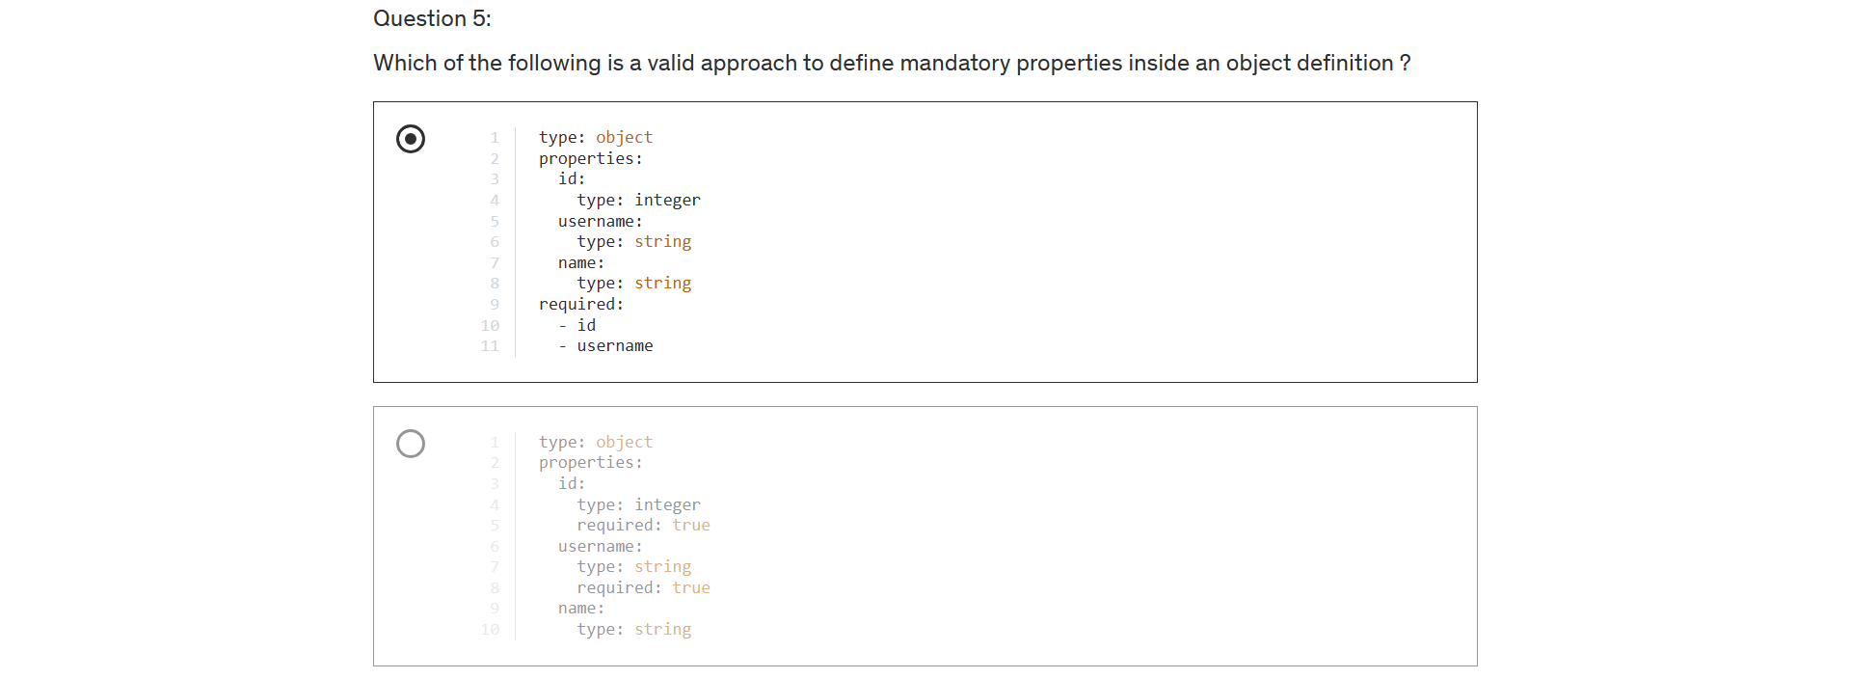
6. A screenshot of a computer

   Description automatically generated
7. A screenshot of a computer

   Description automatically generated
8. A screenshot of a computer

   Description automatically generated
9. A screenshot of a white page

   Description automatically generated